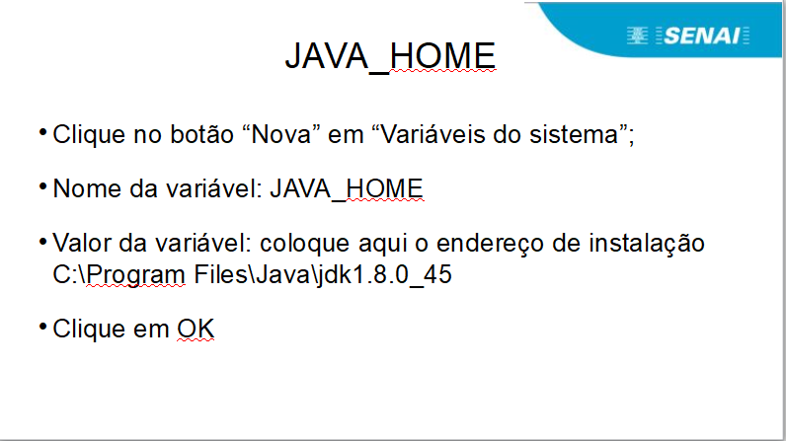
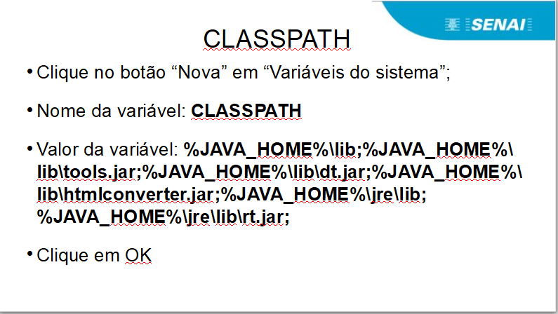
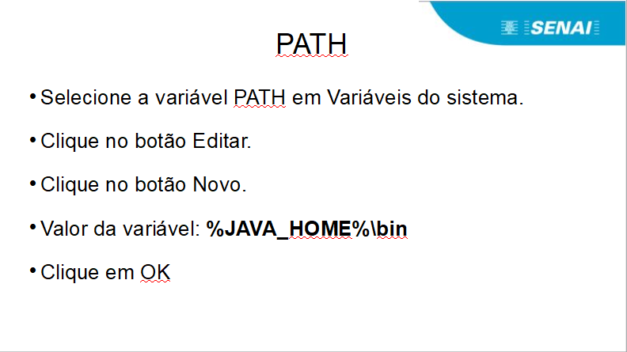
CLASSPATH
%JAVA_HOME%\lib;%JAVA_HOME%\lib\tools.jar;%JAVA_HOME%\lib\dt.jar;%JAVA_HOME%\lib\htmlconverter.jar;%JAVA_HOME%\jre\lib;%JAVA_HOME%\jre\lib\rt.jar;

